**WEB APPLICATION DEVELOPMENT LAB**

**02-01-2025**

Eshwar Deshmukh Chavan

HU22CSEN0100999

Write a JavaScript to validate a form

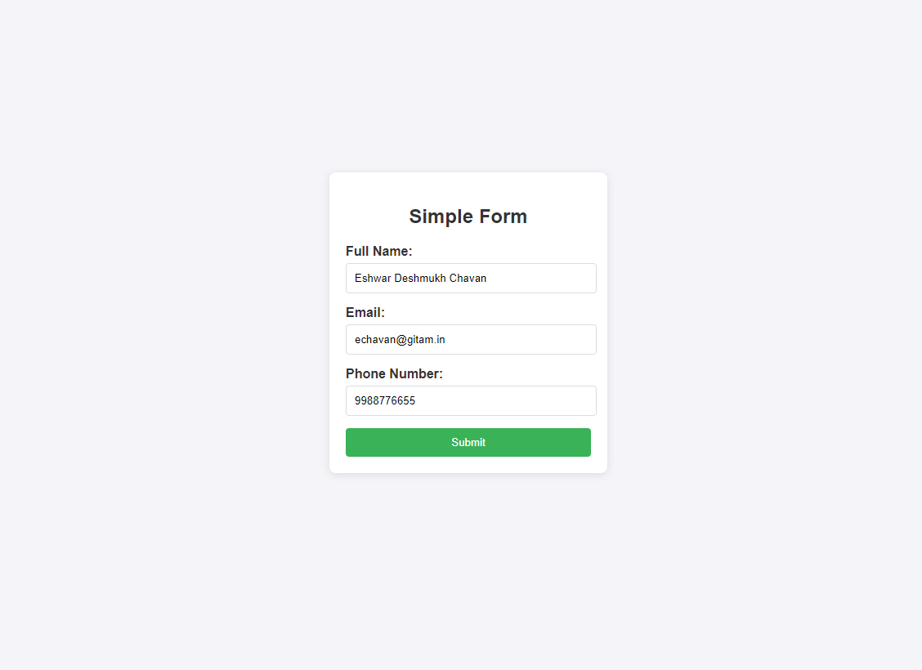

Submitting:

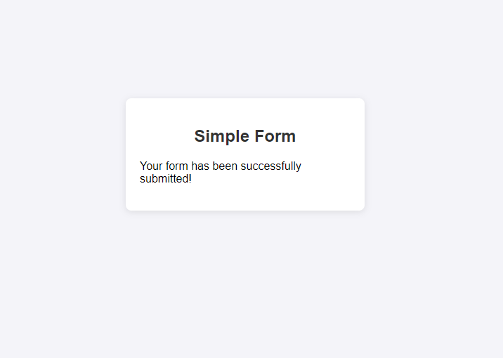

Errors :

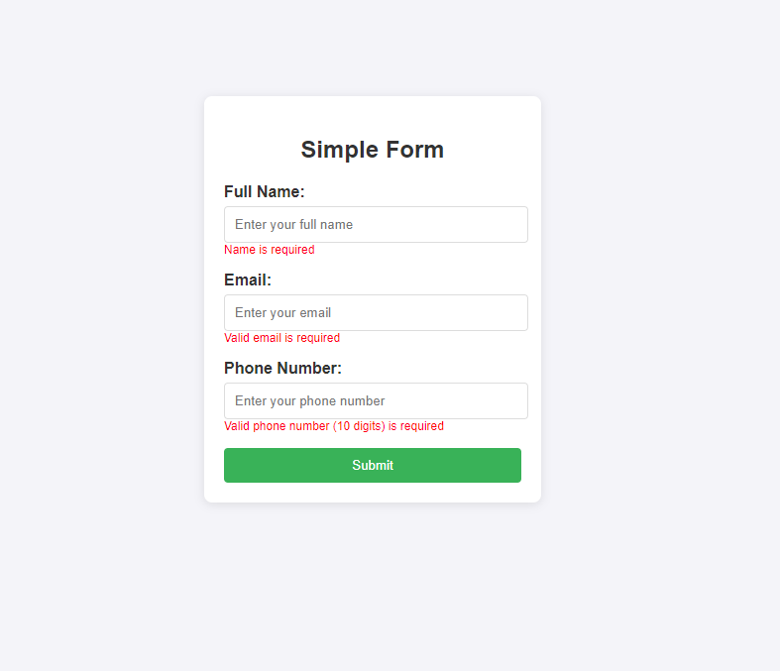

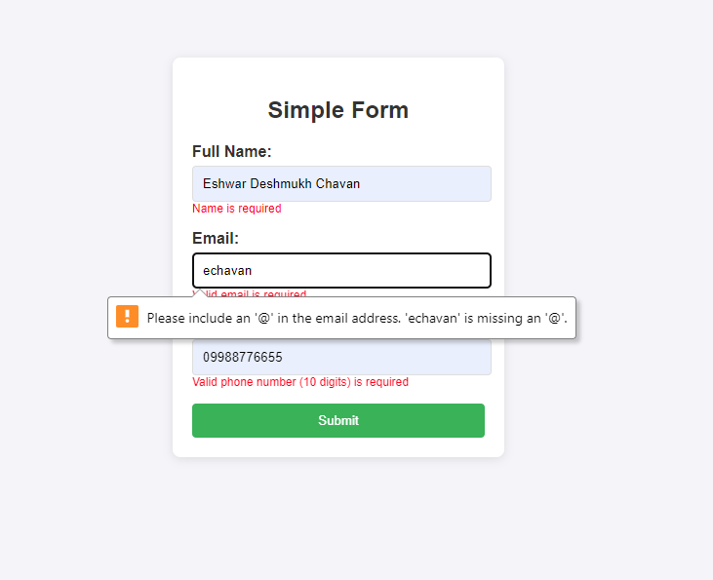

CODE:

<!DOCTYPE html>

<html lang="en">

<head>

<meta charset="UTF-8">

<meta name="viewport" content="width=device-width, initial-scale=1.0">

<title>Form Validation</title>

<link rel="stylesheet" href="styles.css">

</head>

<body>

<div class="form-container">

<h2>Simple Form</h2>

<form id="myForm" onsubmit="return validateForm()">

<div class="form-group">

<label for="name">Full Name:</label>

<input type="text" id="name" name="name" placeholder="Enter your full name">

<span class="error" id="nameError"></span>

</div>

<div class="form-group">

<label for="email">Email:</label>

<input type="email" id="email" name="email" placeholder="Enter your email">

<span class="error" id="emailError"></span>

</div>

<div class="form-group">

<label for="phone">Phone Number:</label>

<input type="text" id="phone" name="phone" placeholder="Enter your phone number">

<span class="error" id="phoneError"></span>

</div>

<button type="submit">Submit</button>

</form>

<!-- Success message section -->

<div id="successMessage" class="success-message" style="display: none;">

<p>Your form has been successfully submitted!</p>

</div>

</div>

<script>

function validateForm() {

let isValid = true;

// Clear previous errors

document.getElementById('nameError').style.display = 'none';

document.getElementById('emailError').style.display = 'none';

document.getElementById('phoneError').style.display = 'none';

// Validate name

const name = document.getElementById('name').value;

if (name.trim() === '') {

document.getElementById('nameError').style.display = 'block';

document.getElementById('nameError').textContent = 'Name is required';

isValid = false;

}

// Validate email

const email = document.getElementById('email').value;

const emailPattern = /^[a-zA-Z0-9._-]+@[a-zA-Z0-9.-]+\.[a-zA-Z]{2,6}$/;

if (email.trim() === '' || !emailPattern.test(email)) {

document.getElementById('emailError').style.display = 'block';

document.getElementById('emailError').textContent = 'Valid email is required';

isValid = false;

}

// Validate phone number

const phone = document.getElementById('phone').value;

const phonePattern = /^[0-9]{10}$/; // Basic validation for 10 digits

if (phone.trim() === '' || !phonePattern.test(phone)) {

document.getElementById('phoneError').style.display = 'block';

document.getElementById('phoneError').textContent = 'Valid phone number (10 digits) is required';

isValid = false;

}

if (isValid) {

// Show success message and hide the form

document.getElementById('successMessage').style.display = 'block';

document.getElementById('myForm').reset(); // Optionally reset the form

document.getElementById('myForm').style.display = 'none'; // Hide form after successful submission

}

return false; // Prevent form from actually submitting

}

</script>

</body>

</html>

Css:

body {

font-family: Arial, sans-serif;

background-color: #f4f4f9;

display: flex;

justify-content: center;

align-items: center;

height: 100vh;

margin: 0;

}

.form-container {

background: white;

padding: 20px;

border-radius: 8px;

box-shadow: 0 2px 10px rgba(0, 0, 0, 0.1);

width: 300px;

}

h2 {

text-align: center;

color: #333;

}

.form-group {

margin-bottom: 15px;

padding-right: 15px ;

}

label {

display: block;

font-weight: bold;

color: #333;

}

input {

width: 100%;

padding: 10px;

margin-top: 5px;

border-radius: 4px;

border: 1px solid #ddd;

}

button {

width: 100%;

padding: 10px;

background-color: #4CAF50;

color: white;

border: none;

border-radius: 4px;

cursor: pointer;

}

button:hover {

background-color: #45a049;

}

.error {

color: red;

font-size: 12px;

display: none;

}